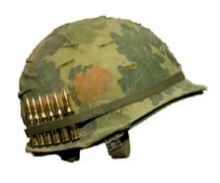**THE IMMUNE SYSTEM |** The body’s line of defence **PEARSON 9** page 261 – 262

The immune system:

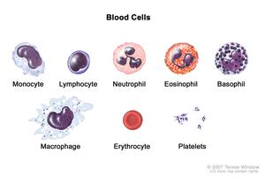**FIRST LINE** -

|  |  |
| --- | --- |
| 1 |  |
| 2 | •  •  • |
| 3 |  |
| 4 |  |
| 5 | •  • |

**SECOND LINE** -

**Starts** when:

**Inflammation**:

**Damaged cells** release:

**Neutrophils**:



**THIRD LINE** -

The **lymphatic** system:

**Macrophages: Lymphocytes:**

Function:

Reason for **swollen lymph nodes**:

**Spleen**:

Reason for a **rise in temperature**:

**Immunity**

•

•